ESSEX COUNTY FIRE AND RESCUE SERVICE
RETIRED MEMBERS ASSOCIATION
NEWSLETTER SEPTEMBER 2023
Secretary: Barry Cable,”Briarlea” Southend Road, Billericay CM11 2PR
Email: barryccable@gmail.com Telephone: 01277 624152 or mobile: 07850 984593
RMA Website: https://www.essex-fire.gov.uk/retired-members-association

The eveWaa
ESSEX COUNTY FIRE AND RESCUE SERVICE
RETIRED MEMBERS ASSOCIATION
NEWSLETTER JUNE 2023
Secretary: Barry Cable,”Briarlea” Southend Road, Billericay CM11 2PR
Email: barryccable@gmail.com Telephone: 01277 624152 or mobile: 07850 984593
RMA Website: https://www.essex-fire.gov.uk/retired-members-association

The eveWaa

____________________________________________
Garden Visit….
The visit to Brian & Wendy Wickenden’s garden on the 2nd August was enjoyed by all who attended. We were very lucky with the weather and had only one shower of rain!
Their garden, as we have come to expect, was of a very high standard and it is obvious that Wendy and Brian are perfectionists putting in many hours of hard work throughout the year!

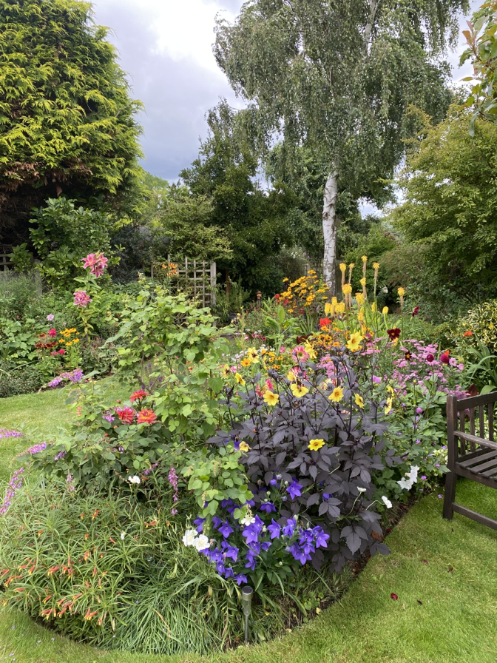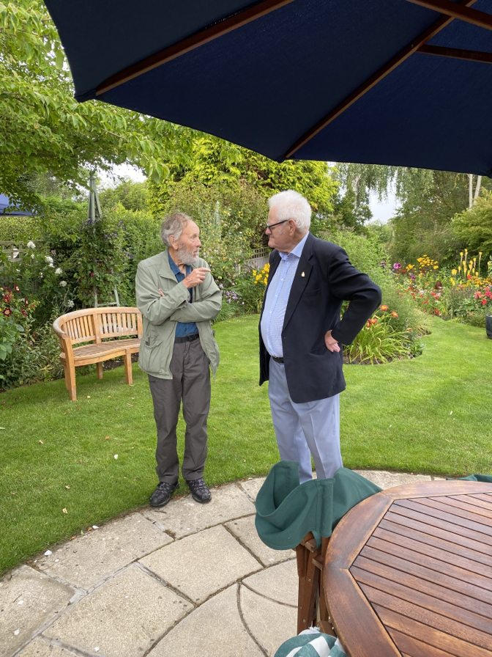

Our thanks to Brian and Wendy for their hospitality.
______________________________________________________________________________
A New Treasurer…
The committee would like to welcome Gillian Day who will be working alongside Graham Farrell with the intention of taking over as the RMA Treasurer when Graham stands down. Many of you will know Gillian from her time in reception at Service Headquarters.
Forthcoming Events:-
Thursday 5th October 2023 – Traditional Afternoon Tea
Those who have been to an RMA Afternoon Tea will know that it is a delightful event, meeting up with old friends. By popular demand we are back at the Tiptree Tea Rooms, The Barns, Cressing Temple, Witham Road, Cressing CM77 8PD, where the staff there always looks after us very well. Visitors can make their way around the fascinating and outstanding 13th century barns and admire the Tudor herb garden. Tiptree Barns has a well-stocked shop; amongst the regular jars and pots you will find they are now even producing fruit infused alcohol, the ideal gift!
See attached flyer for further details …….
Thursday 7th December 2023 – Christmas Lunch
This year we have decided to hold our Christmas Lunch at The Lion Inn at Boreham in their private dining room. We had an excellent lunch there in the summer of 2022 and we know, the food and service are of a very high standard.
See attached flyer for further details …….

NEW MEMBERS WANTED
Do you know anyone who is retiring from the Service and would like to become a member of the RMA for only £3 per year? They will receive a birthday card each year and be kept up to date with the Newsletters, plus details of all events etc.
Please email the RMA Secretary at
barryccable@gmail.com

Let’s ensure that all retired ECFRS personnel are able to keep in touch
with their former colleagues

Christmas Lunch at the Lion Inn
Main Road, Boreham, Chelmsford, CM3 3JA
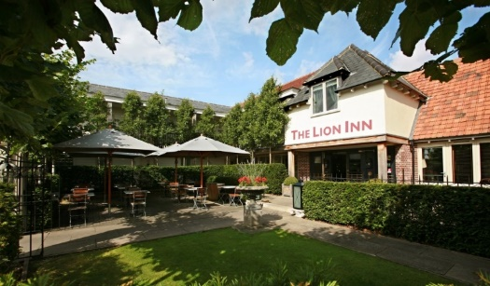
The Date :- 7th December 2023
Time :- 12 noon for 12.30pm
Price :- £38.95 per person
This is for a 3-course meal with tea/coffee (choose your menu on the day)
See menu attached
This year we are holding our Christmas Lunch at the Lion Inn as we know the quality of food and the service we have received in the past is very good.

We have reserved the private dining room for this event and our numbers for seating are limited so please book early to secure your places!

Register your interest in this event by emailing John Rogers at
dj.rogers@btinternet.com
along with one of the following payment methods

There are two methods of payment:
by online banking as follows:
Account: ECFRS RMA, sort code: 30-91-85, account number: 49411768,
Please use reference: “Xmas [surname]”
(so that we know how to attribute the payment)

or alternatively:
forward a cheque made payable to ECFRS RMA to
John Rogers – 1 Ruffles Close, Rayleigh, SS6 8EW

