ESSEX COUNTY FIRE AND RESCUE SERVICE
RETIRED MEMBERS ASSOCIATION
NEWSLETTER OCTOBER 2023
Secretary: Barry Cable,”Briarlea” Southend Road, Billericay CM11 2PR
Email: barryccable@gmail.com Telephone: 01277 624152 or mobile: 07850 984593
RMA Website: https://www.essex-fire.gov.uk/retired-members-association

The eveWaa
ESSEX COUNTY FIRE AND RESCUE SERVICE
RETIRED MEMBERS ASSOCIATION
NEWSLETTER JUNE 2023
Secretary: Barry Cable,”Briarlea” Southend Road, Billericay CM11 2PR
Email: barryccable@gmail.com Telephone: 01277 624152 or mobile: 07850 984593
RMA Website: https://www.essex-fire.gov.uk/retired-members-association

The eveWaa

____________________________________________
Studley Castle Visit….
Another successful RMA 4-day break, this time to the impressive Studley Castle in Warwickshire. Thanks to Dave and Jean Birks for organising a brilliant event.
During the time there we had the opportunity to visit the British Motor Museum, Warwick Castle and the GWSR Heritage Steam Railway running from Broadway to Cheltenham. Spending a sunny afternoon having a Cream Tea in Broadway. Some took the opportunity to make use of the Castle facilities e.g., Spa and Pool.
The food provided was varied and of a high standard. Mealtimes offered us the chance to meet up and discuss our day.
All this combined with swinging the lamp of an evening with like-minded excellent company. As the evenings progressed, the stories were embellished. Why let the truth get in the way of a good tale. The constant laughter was jaw aching.
[RMA Committee member: Ray Parfitt]
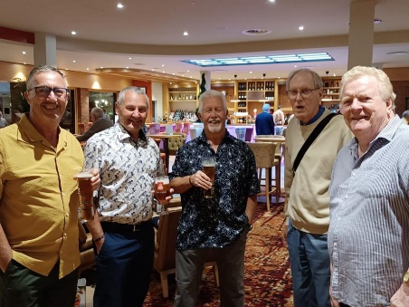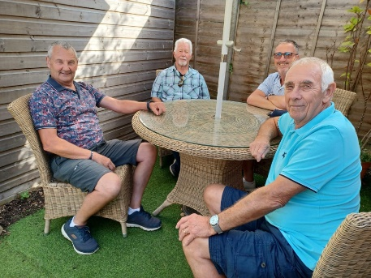
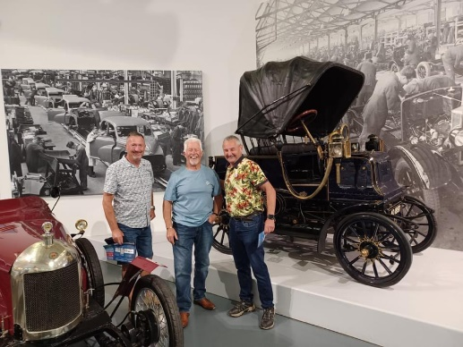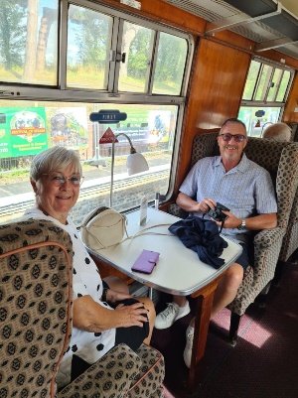
Forthcoming Events:-
Thursday 5th October 2023 – Traditional Afternoon Tea
Those who have been to an RMA Afternoon Tea will know that it is a delightful event, meeting up with old friends. By popular demand we are back at the Tiptree Tea Rooms, The Barns, Cressing Temple, Witham Road, Cressing CM77 8PD, where the staff there always look after us very well. Visitors can make their way around the fascinating and outstanding 13th century barns and admire the Tudor herb garden. Tiptree Barns has a well-stocked shop; amongst the regular jars and pots you will find they are now even producing fruit infused alcohol, the ideal gift!
Just a few places left – book now to avoid disappointment
See attached flyer for further details …….
Thursday 7th December 2023 – Christmas Lunch
This year we have decided to hold our Christmas Lunch at The Lion Inn at Boreham in their private dining room. We had an excellent lunch there in the summer of 2022 and we know, the food and service are of a very high standard.
There are only a few places left for this event, so you need to book now!
See attached flyer for further details …….
Hospital & Medical Care Association
Following contact from the HMCA (Hospital & Medical Care Association) the RMA committee suggested that we should make the HMCA information available to members as outlined in the attached flyer.
Members are advised that the RMA accepts no responsibility whatsoever should any member act upon the information provided, and neither is this a recommendation. The RMA is purely passing on the information without prejudice, and any liaison would be strictly between the member and the HMCA.
See attached flyer for further details …….

NEW MEMBER
The RMA is very pleased to welcome Danny Bruin as a new member.
Christmas Lunch at the Lion Inn
Main Road, Boreham, Chelmsford, CM3 3JA
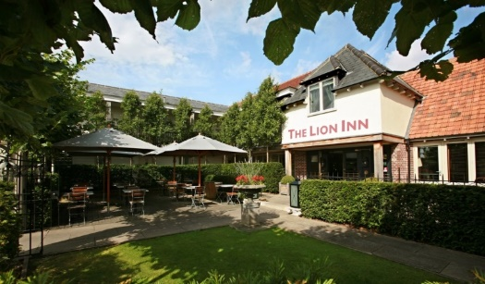
The Date :- 7th December 2023
Time :- 12 noon for 12.30pm
Price :- £38.95 per person
This is for a 3-course meal with tea/coffee (choose your menu on the day)
See menu attached
This year we are holding our Christmas Lunch at the Lion Inn as we know the quality of food and the service we have received in the past is very good.

We have reserved the private dining room for this event and our numbers for seating are limited so please book early to secure your places!

Register your interest in this event by emailing John Rogers at
dj.rogers@btinternet.com
along with one of the following payment methods

There are two methods of payment:
by online banking as follows:
Account: ECFRS RMA, sort code: 30-91-85, account number: 49411768,
Please use reference: “Xmas [surname]”
(so that we know how to attribute the payment)
or alternatively:
forward a cheque made payable to ECFRS RMA to
John Rogers – 1 Ruffles Close, Rayleigh, SS6 8EW

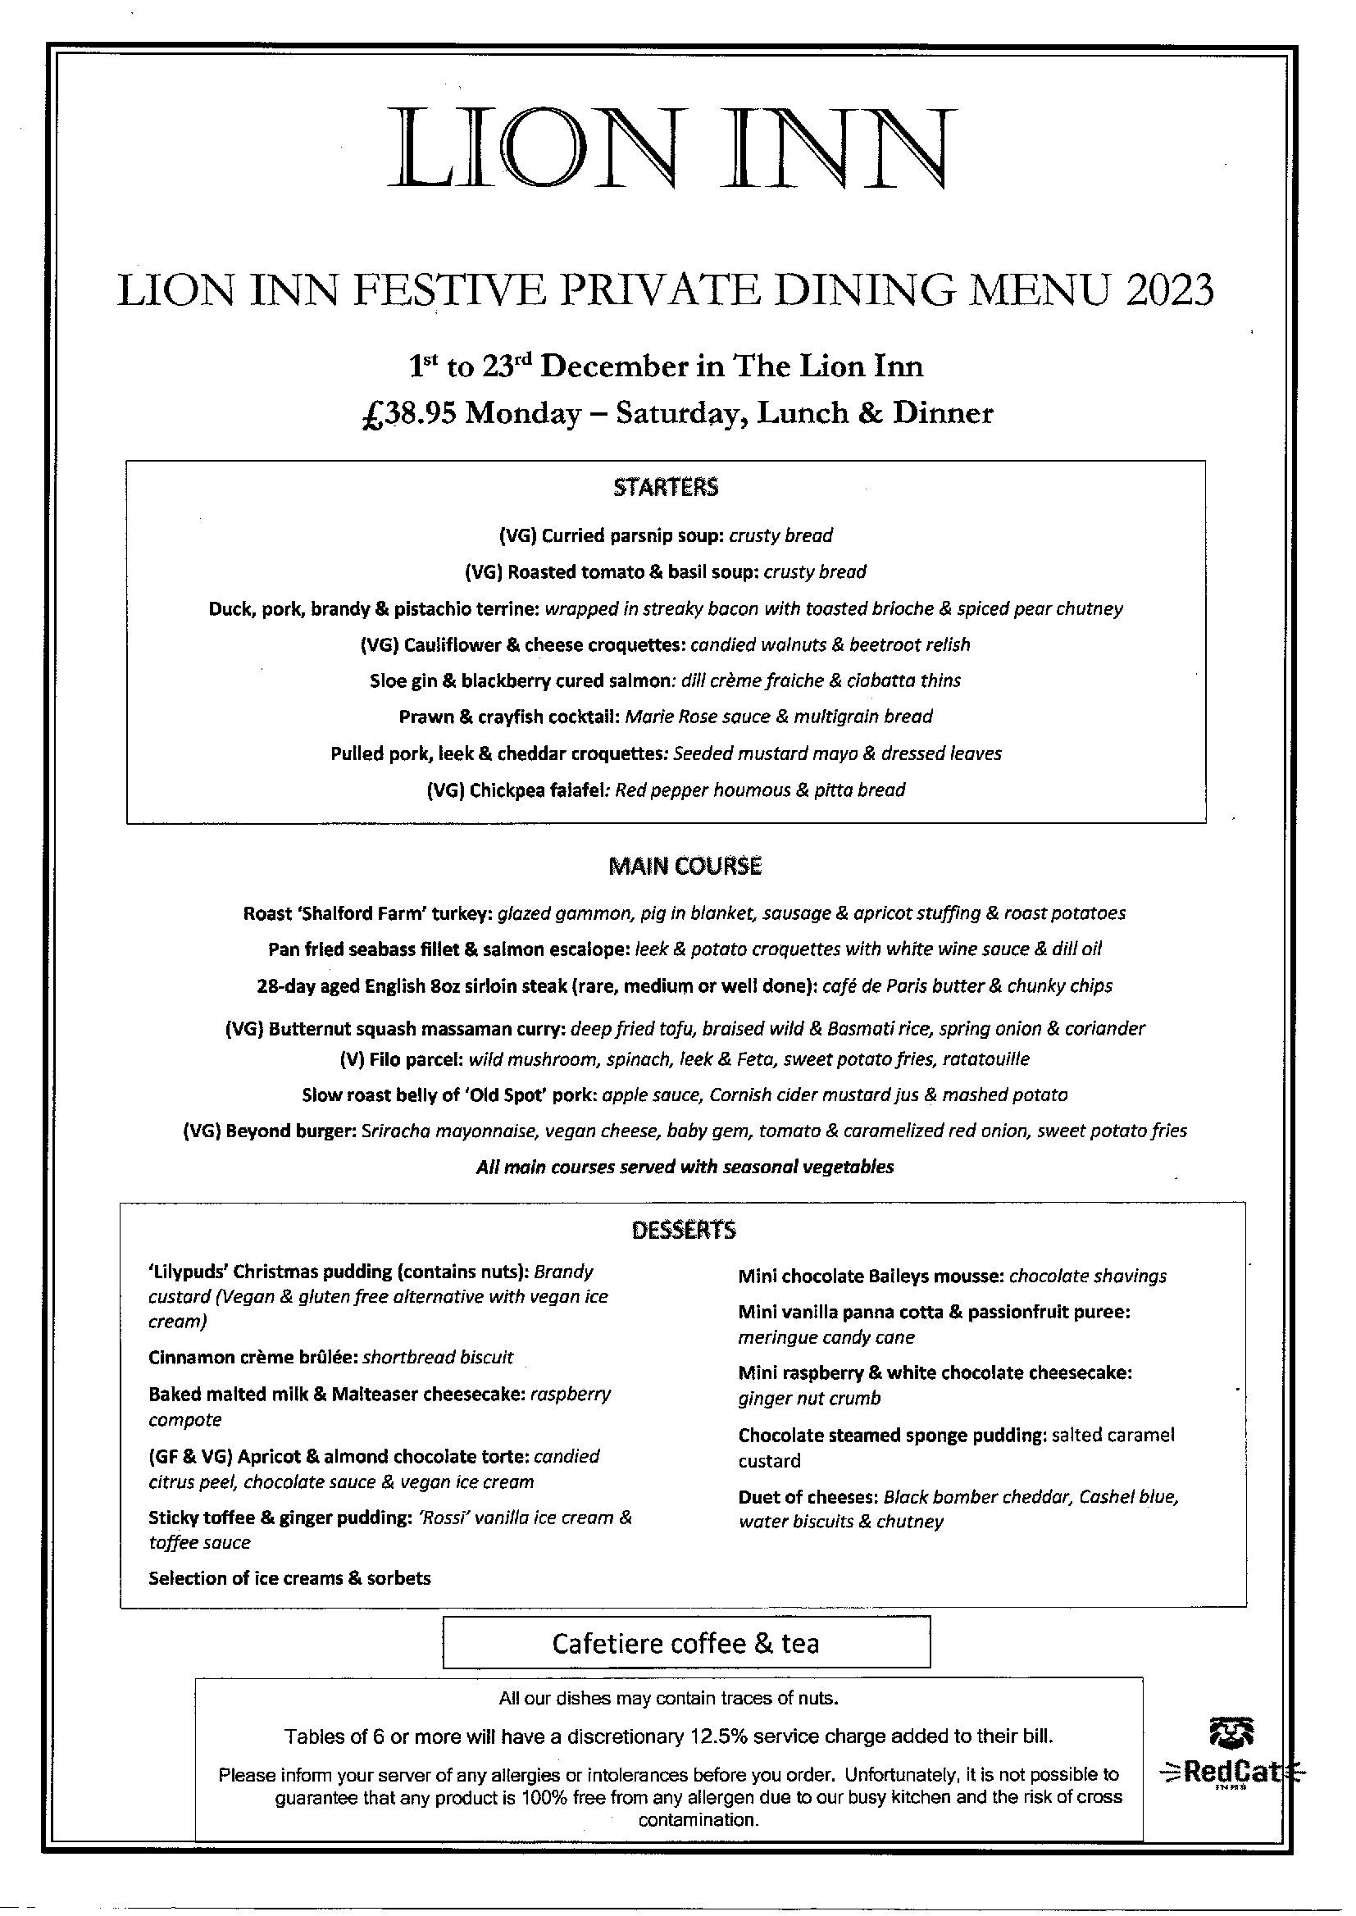

THERE ARE JUST FOUR PLACES LEFT
This is an opportunity to meet up with your friends and former colleagues
Come and join us at the RMA’s …
TRADITIONAL AFTERNOON TEA
There are few hours in life more agreeable than the time dedicated to the ceremony known as Afternoon Tea.-- Henry James
Never trust a man who, when left alone in a room with a tea cosy, doesn’t try it on. –- Billy Connelly
Come, let us have some tea and continue to talk about happy things -- Chaim Potok
Tiptree Tea Room at The Barns, Cressing Temple,
Witham Road, Cressing CM77 8PD
Suitable for wheelchair users or visitors with limited mobility
12 noon until 3.30 p.m.
Thursday 5th October 2023
Cost: £17.50 per head
If you would like to attend this event,
please forward a cheque made payable to ECFRS RMA to
The RMA Secretary, “Briarlea” Southend Road, Billericay CM11 2PR
Alternatively reserve your places by email to barryccable@gmail.com
and pay by online banking as follows:
Account: ECFRS RMA, sort code: 30-91-85, account number: 49411768,
reference: Tea [surname]

EXTRACTS FROM THE SEPTEMBER EDITION OF THE ECFRS NEWS
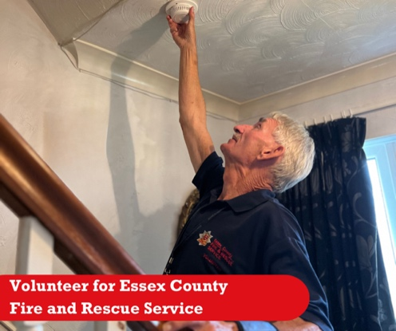
Want to continue to support ECFRS after retirement? Join us and become a volunteer for your community!
We have many opportunities for retired firefighters to get involved with, from talking to Essex residents about home fire safety to volunteering at the museum.
Find out more here: https://www.essex-fire.gov.uk/volunteering

Keep your family and home safe by
following our chimney safety advice:

- Have your chimney swept at least once a year, or more frequently if you burn wood
- Do not stack fires too high and remember to let them burn down well before you go to bed
- Use a fire or spark guard
- Do not place objects on or over the mantelpiece which may cause you to lean over the fire to reach them
- Inspect your chimney regularly - particularly in the roof space - to ensure that it is sound and that sparks or fumes cannot escape through cracks or broken bricks
- Avoid burning soft woods as resin and soot builds up more quickly
- Buy suitable fuels. Using the wrong type of fuel on a liner will cause corrosion and reduce the life of the liner

