ESSEX COUNTY FIRE AND RESCUE SERVICE
RETIRED MEMBERS ASSOCIATION
NEWSLETTER MAY 2023
Secretary: Barry Cable,”Briarlea” Southend Road, Billericay CM11 2PR
Email: barryccable@gmail.com Telephone: 01277 624152 or mobile: 07850 984593
RMA Website: https://www.essex-fire.gov.uk/retired-members-association

The eveWaa

____________________________________________
WELCOME TO THE MAY NEWSLETTER

ANNUAL GENERAL MEETING

The Annual General Meeting was held on the 15th April at the Essex Fire Museum, Grays Fire Station, Hogg Lane, Grays, and was well attended by approximately 30 people in the Museum conference room which was very “cosy”.

The Chairman gave thanks to Janet Caldwell and Lin Parfitt for running the raffle which raised in excess of £100. Thanks also to those members who contributed with raffle prizes. He also gave thanks to John & Diane Rogers for arranging the venue for the meeting and the light refreshments.

The minutes of the meeting are attached.

AFTERNOON TEA

For the second year in succession members attended the afternoon tea at the Barns, Cressing Temple. Once again this was a very successful event and thanks to Jan & Barry Cable for organising it.

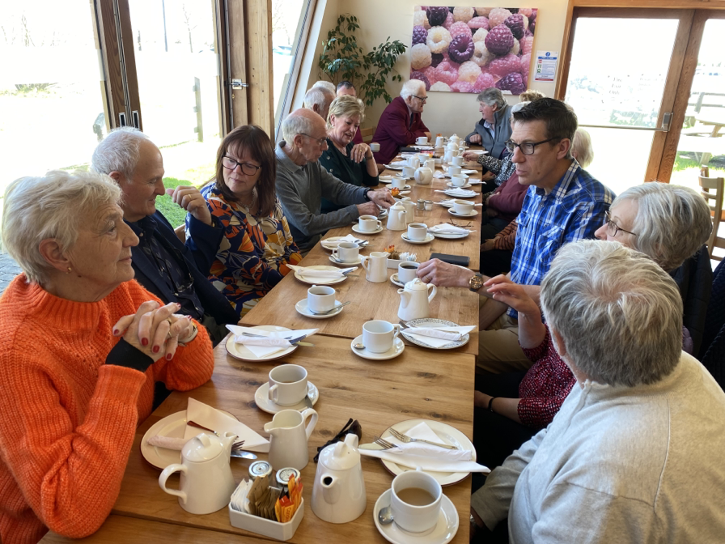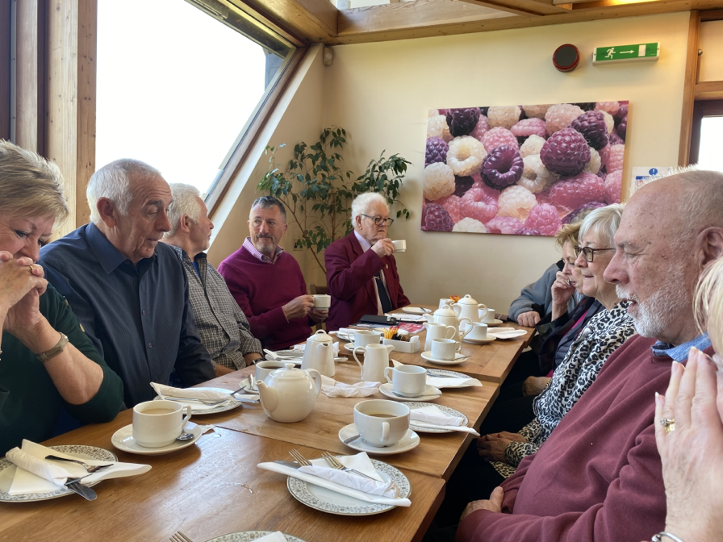

FORTHCOMING EVENTS

JUNE
RAF MUSEUM AT HENDON – 14TH June 2023
A visit to the RAF Museum at Hendon on 14th June 2023.
Please note that there is an amendment to the price due to a change of coach company.
Monies are now due, please see attached flyer.

JULY
GREYHOUND RACING AT ROMFORD STADIUM – 7TH JULY 17.30Hrs
Enjoy an evening of greyhound racing at Romford Stadium with a 3-course meal in the Paddock Restaurant. Overlooking the winning line, the Paddock Restaurant is set out across two tiers and offers excellent views of the racing action. It really is the place to be on race nights!
Booking details regarding this event can be found on the attached flyer.

AUGUST
GARDEN VISIT – 2ND August 2023
A visit to Brian & Wendy Wickenden’s superb garden at St Osyth with afternoon tea & cake.
Details to be included in the June newsletter.

SEPTEMBER
4-NIGHT STAY AT STUDLEY CASTLE, WARWICKSHIRE - 11TH September 2023
There are still a few places available for the Warners Getaway to Studley Castle, Warwickshire, see flyer attached for details.

NEW MEMBERS
The RMA is very pleased to welcome Alan Woods and Trevor Pateman as new members.

ESSEX COUNTY FIRE AND RESCUE SERVICE RETIRED MEMBERS ASSOCIATION RMA
RAF Museum, Hendon Trip Wednesday 14th June 2023
The RAF Museum Hendon, Grahame Park Way, London, NW9 5LL
The coach fare for this event will be £31.00 per person (this does not include a driver’s gratuity). Entrance to the museum is free!
Payment should now be made by one of the following options.

There are two methods of payment:
- by online banking as follows: Account: ‘ECFRS RMA’, sort code: 30-91-85, account number: 49411768, Please use reference: ‘RAF Hendon’ (+ your surname)’ so that we know how to attribute the payment or,
- alternatively forward a cheque made payable to ECFRS RMA to John Rogers, 1 Ruffles Close, Rayleigh, SS6 8EW.
The coach will collect from Hawkwell Fire Station at 08:30hrs, before proceeding to Billericay Fire Station at 09:00hrs, with parking available at both sites. If members attending can indicate their preferred pick-up point (Billericay or Hawkwell) by emailing Martin Pullen this will assist the coach driver.
There are still places available. If you are interested, please contact Martin Pullen by email pullenmartin34@gmail.com or by phone/text 07979-707536.
The museum is open from 10:00hrs to 17:00hrs and we expect to leave the museum at 16:00hrs for the return trip.

Join your fellow RMA members at…

GREYHOUND RACING AT ROMFORD STADIUM
The RMA is bringing together a group of members to attend a race meeting which will be held in July. We’ve chosen the July date because of the lighter nights, and it might make it easier for some people to get home.

Details are:
Date: Friday evening 7th July 2023
Time: Gate open at 17:30 hrs and members to be there by 18:00 hrs
Travel: Own Transport. (parking is available on a first come-first-served basis.)
Please inform us of any allergies, dietary requirements, accessibility needs, or wheelchair users.

Tickets are £37.50 per person which includes:
Admission and Racecard
3-course meal in the Paddock Restaurant
Drinks Table Service
Tote Messenger Betting Service

Please reserve your places by email to
Tony Pizzala: tonypizzala1950@gmail.com
There are two methods of payment:
by online banking as follows:
Account: ECFRS RMA, sort code: 30-91-85, account number: 49411768,
Please use reference: “Rom Dogs [surname]”
so that we know how to attribute the payment.
or alternatively:
forward a cheque made payable to ECFRS RMA to
The RMA Secretary, “Briarlea, Southend Road, Billericay CM11 2PR

Important: Please note that once final figures are given to the venue,
refunds cannot be made for non-attendance.
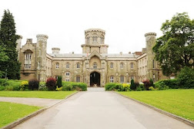
Warners Hotel Getaway at Studley Castle, Warwickshire
11th September 2023
5 days, 4 nights with breakfast & dinner
Studley Castle, Hardwick Lane, Studley,
B80 7AJ

Last year Heythrop Park was a huge success and all those that visited are returning to Studley Castle this September.
Warners Hotels offer outstanding service with excellent dining.
Included in the price
- Breakfast every day
- Three-course evening dinner
- Daily live music and entertainment
- Full access to pool & Sauna
- Free parking & Wi-Fi
- History & Grounds tour

“Studley Castle is nestled in the glorious Warwickshire countryside, an area best known as Shakespeare's England. Stratford Upon Avon, Shakespeare's birthplace, is a must see, and where you can experience historic sites, or stroll alongside the canals and perhaps enjoy a refreshing drink at one of the many pubs. Also close by is picturesque Henley-in-Arden, the charming town of Warwick, with its timber-framed houses and more notably Warwick Castle. Venture a little further afield and you can admire the villages and countryside of the Cotswolds”.
Travel by car would be the best way to attend, but car sharing could be an advantage.
The cost, which includes a group discount is £454 per person for a standard room accommodation.
Three single rooms are available without supplement
A deposit of £20 per person is required to secure your booking.
Account: ECFRS RMA, Sort Code 30-91-85, Account Number 49411768 Reference: Studley Castle
Alternatively, a cheque payable to ECFRS RMA to Graham Farrell
95 Washington Road, Maldon, Essex, CM9 6JF

If you need further information, please contact Dave Birks: 01702 528355
dave-jean-birks@supanet.com
or visit the Warners Studley Castle website for full details.

Throwing out a fire extinguisher?
The ECFRS often gets asked how to dispose of an old fire extinguisher.
Fire extinguishers from your own household can be taken to any Essex County Council recycling centre.
There is lots of information on the Love Essex website - just type in whatever it is you want to dispose of, and it will tell you the best place to take it.

OBITUARIES
MICK HUGHES.
We are sorry to have to bring you the very sad news that Mick Hughes died on Monday 10th April.

Mick moved from the London Fire Brigade to Essex in the late 60s. When he retired, he joined the ECFRS Retired Members’ Association and remained a member for over 25 years, fifteen of which he held the role of Honorary Treasurer. He finished his career in the Service as ACO.

His funeral will be held on Wednesday 10th May at 10:30 hrs at Chelmsford Crematorium, Writtle Road, Chelmsford CM1 3BL. Donations to Leukaemia UK, 52 Portland Place, London W1B1NH or floral tributes to F.E.Farrer, Funeral Directors, 33 High Street, Billericay CM12 9BA.
_____________________________________
GORDON EVERSON
We are also sorry to bring you the sad news that our fellow member Gordon Everson died on Monday 27th March 2023. This information has only just reached us.

Gordon served at Frinton as a retained firefighter for 24 years between 1964-1988.
Unfortunately, we haven’t been able to find out any details about the funeral. It may be that it has already taken place.
_______________________________

ROGER PARAMOR
We are truly sorry to bring you the sad news that our ex Chief Officer Roger Paramor died on the 30th April 2023.
There are currently no funeral details, but they will be published as soon as the information becomes available.

_{Th}
ESSEX COUNTY FIRE AND RESCUE SERVICE
RETIRED MEMBERS ASSOCIATION

ANNUAL GENERAL MEETING
held at 14.00 hrs on Saturday 15th April 2023
The Essex Fire Museum,
Fire Station, Hogg Lane Grays RM17 55QS
_________________________________________
Members Present:
John Smith in the Chair
Dave Birks, Barry Cable, Janice Cable, Barry Cooper, Ken Deex, Ann Edgell, Graham Farrell, Jon Fincham, Ed Goward, Ann Horton, Chris Hunt, Ray Parfitt, Tony Pizzala, Martin Pullen, John Rogers, Diane Rogers, Peter Sigournay, Graham Springs, Alan Stone,
Guests:
Jean Birks, Theresa Deex, Sue Farrell, Linda Parfitt, Jackie Sigournay, Floss Stone
1) Apologies for absence
The Secretary reported apologies for absence from: Janet Baker, Keith Baxter, Steve Blackwell, Gwen Boulter, Shaun Cornish, Michael Dedman, Frank Geraghty, David Hadjicostas, Norman Hardman, Tim Hinds, Val Hole, Neil Holloway, Hazel Humphrey, Pat Jones, Ron Murray, John Sherrington, Jill Stevens, Barry Unger, Mark Wilson, Eileen Winslow, Les Wren, Terry Wright, Jason Thompson.
2) Minutes
The minutes of the Annual General Meeting held on Saturday 28th May 2022 were accepted as a true and accurate record of the meeting.
3) Matters Arising
There were no matters arising.
4) Report from the Chairman
The Chairman thanked everyone for attending the meeting.
The Chairman conveyed his thanks to the Secretaries, Janice and Barry Cable, for ensuring donations were made to designated charities on behalf of the Association at the passing of members. Gratitude was also expressed to Linda Boar who was responsible for sending members their birthday cards.
Dave Birks organised a very successful visit to Warner’s Leisure Hotel, Heythrop Park which was the first time the association had ventured into the realms of a four-night event. Everyone who went on the trip said it was excellent, so much so, that by popular demand a similar excursion is being arranged for 11th September 2023, when a party from the RMA will visit Studley Castle in Warwickshire. Places are still available, and anyone interested should contact Dave Birks.
Diane and John Rogers are to be thanked for organising an excellent lunch at the Lion Inn at Boreham, and a Christmas lunch at The Crown, Sandon. They were also responsible for arranging today’s meeting in the Museum and delivering the refreshments.
A serious situation is evolving within the RMA in that not many new members were coming into the Association and the Chairman emphasised that if new blood could not be encouraged to join, the Association’s future was looking grim. The new Chief Executive/Chief Fire Officer, Rick Hylton, confirmed at a meeting with the Committee on 19th January, that the RMA has his full support and in a personal letter to all firefighters who were about to retire, he encouraged them to join the Association. The Chief has asked to meet with the Committee again in October.
The Secretaries recently experienced a difficulty with ECFRS Corporate Communications when the decision was taken, without warning, that they were no longer going to send out any RMA notifications to the members by email. It was suggested that it was an easy task to cut and paste the 280 email addresses from the main database. However, this was not the case as the internet provider used by the Secretaries was a personal account which did not allow the sending of emails with multiple addresses. After a great deal of time investigating, a method was established which allowed the RMA to have full control of all its communications.
The Chairman read out the names of the members deceased since the last meeting:
Bob Austin, Ron Bridges, Albert Copping, John “Sam” Green, Mick Hughes, Bob Hurley, Martyn “Taffy” James, Roy Larby, Mary Law, Ray O’Neil, Vince Underwood, Keith Webster
5) Report from the Secretary
The Chairman had already covered the situation regarding the sending out of emails to members. It took a great deal of time and effort to establish a usable method, and once created, the circumstance has already benefitted the RMA as all missives are now being sent out immediately, which is essential when there is a short take-up time for events such as the booking of theatre tickets.
When working on the scheme to be adopted for sending out the emails, it became apparent that a number of email addresses were bouncing each month and the RMA was not previously advised of this. About 10 email addresses were not being delivered, but this has now been reduced to just two. The Secretary underlined how important it was to keep the RMA informed when any members changed their email address, and, of course, all contact details.
6) Report from the Membership Secretary
There are currently 289 members on the database. Ten new members have joined since the last AGM. Twelve members deceased since the last AGM as read out by the Chairman.
7) Report from the Treasurer
The Treasurer presented the income and expenditure for the year ended 31st December 2022 - there were no matters arising.
8) Subscription rates for 2022/2023
The Chairman stressed that increasing costs, including the recent rise in the cost of postage stamps, will be placing a strain on the future finances of the Association. The Committee had discussed this at its last meeting and by majority vote decided that the subscription should be increased to £3.00 per annum as from 1st April 2024. This decision has to be ratified by the RMA members in general meeting. A question from the floor asked why the increase could not be implemented now and the Chairman explained that current funds were sufficient to carry the RMA through until April 2024, and to increase the subscriptions immediately would cause a problem with Standing Orders which will have to be increased. The start of the new subscription year commencing 1st April 2024 would be the most practical time for members to instruct their banks to make the adjustment to their Standing Orders.
The suggestion was made that rather than sending out birthday cards to the members, the greetings could be sent by email. As the RMA still had a supply of cards for the next couple of years, and a number of members had indicated that they appreciated receiving a card every year, the traditional acknowledgement of members’ birthdays with a card would continue. A member warned that if the Royal Mail’s plan to make the cost of postage stamps regional came to fruition, this might require a future rethink on the sending of birthday cards.
The proposal to increase the annual subscription to £3 per annum as from 1st April 2024 was endorsed by a unanimous show of hands. The proposal was therefore carried.
9) Election of Officers
Committee Members:
Chair: John Smith, Secretaries: Barry Cable, Janice Cable, Membership Secretary and Treasurer Graham Farrell. Other Committee Members: Janet Baker, Dave Birks, Linda Boar, Janet Caldwell, Ray Parfitt, Tony Pizzala, John Rogers, Diane Rogers.
The Chairman and the Secretary said that they are both prepared to stand for another year. The Honorary Treasurer and Membership Secretary has had to resign from his position because of health problems, but will continue assisted by his wife, until replacements have been found. The Association was therefore looking for new people for these posts and the Chairman asked to be advised if someone knew of anyone who might be willing to take up these positions.
The Chairman asked if anyone at the meeting would like to join the Committee. Jon Fincham indicated that before he volunteered to join the Committee, he would like to attend the next Committee meeting to determine the experience of being part of the group. The meeting confirmed that the current Committee should be re-elected en bloc.
The Chairman gave his thanks to all members of the Committee for their support.
10) Events
The next event is the Traditional Afternoon Tea at the Tiptree Tea Rooms at The Barns, Cressing Temple on Thursday 20th April, which is just 5 days away. The RMA has returned to this venue by popular demand, but there are still a few places available.
On Wednesday 14th June, Martin Pullen has organised a trip to The Royal Air Force Museum Hendon. There are still a couple of places to be filled.
Friday 7th July will see a party of members visiting Greyhound Racing at Romford Stadium. Reservations are open and Tony Pizzala is organising the event.
A Warner Hotel five-day event is planned for 11th September and there are four places to be filled to complete the complement. Dave Birks is the organiser.
The Chairman once again emphasised that the RMA needs the support of the members for organised events, but he also said that unless a suitable period of notice of non-attendance is given, refunds will not be possible, and the onus is on the member to resell his/her place(s). A member suggested that insurance could be taken out against members’ inability to attend an event already booked. She said in her experience suitable insurance could be obtained for as little at £14.00.
11) Any Other Business
There was no other business.
The business of the 2023 Annual General Meeting concluded at 3 p.m.

