ESSEX COUNTY FIRE AND RESCUE SERVICE
RETIRED MEMBERS ASSOCIATION
NEWSLETTER JULY 2023
Secretary: Barry Cable,”Briarlea” Southend Road, Billericay CM11 2PR
Email: barryccable@gmail.com Telephone: 01277 624152 or mobile: 07850 984593
RMA Website: https://www.essex-fire.gov.uk/retired-members-association

The eveWaa
ESSEX COUNTY FIRE AND RESCUE SERVICE
RETIRED MEMBERS ASSOCIATION
NEWSLETTER JUNE 2023
Secretary: Barry Cable,”Briarlea” Southend Road, Billericay CM11 2PR
Email: barryccable@gmail.com Telephone: 01277 624152 or mobile: 07850 984593
RMA Website: https://www.essex-fire.gov.uk/retired-members-association

The eveWaa

____________________________________________
A Great Day at RAF Hendon…..
Our thanks to Martin Pullen for organising a successful visit to RAF Hendon.
The museum itself had excellent facilities and a wonderful array of aircraft from the days of early flight right up to modern times.
Despite the problems Martin had with booking the transport, the trip to Hendon was a huge success and everyone enjoyed a great day out.

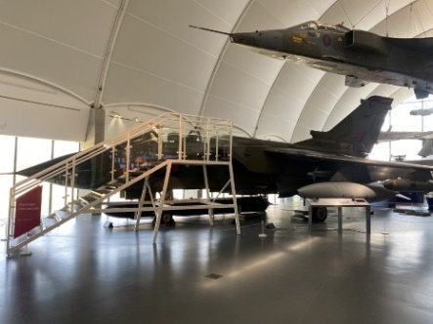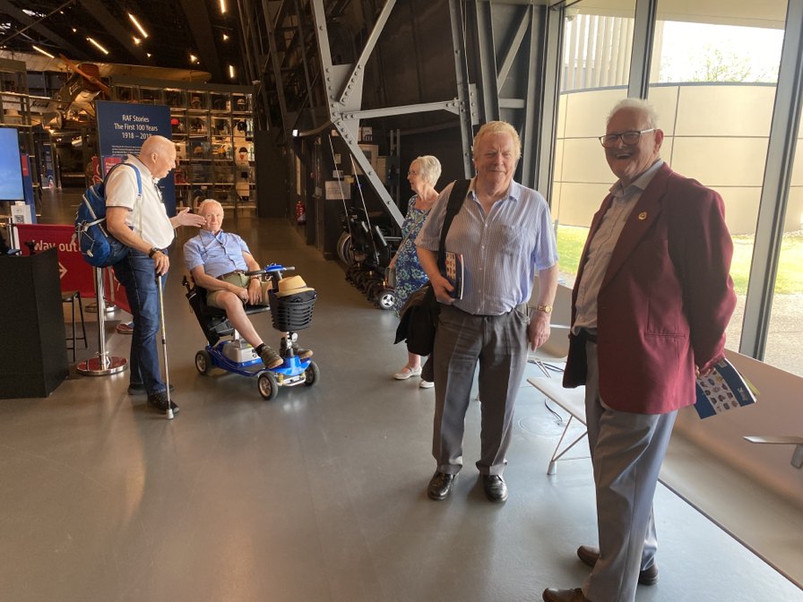
Well done Martin!

Forthcoming Events:-

GREYHOUND RACING AT ROMFORD STADIUM
The RMA is bringing together a group of members to attend a race meeting which will be held in July. We’ve chosen the July date because of the lighter nights, and it might make it easier for some people to get home.

Details are:
Date: Friday evening 7th July 2023
Time: Gate open at 17:30 hrs and members to be there by 18:00 hrs
Travel: Own Transport. (parking is available on a first come-first-served basis.)
Please inform us of any allergies, dietary requirements, accessibility needs, or wheelchair users.

Tickets are £37.50 per person which includes:
Admission and Racecard
3-course meal in the Paddock Restaurant
Drinks Table Service
Tote Messenger Betting Service

Please reserve your places by email to
Tony Pizzala: tonypizzala1950@gmail.com
There are two methods of payment:
by online banking as follows:
Account: ECFRS RMA, sort code: 30-91-85, account number: 49411768,
Please use reference: “Rom Dogs [surname]” so that we know how to attribute the payment.
or alternatively:
forward a cheque made payable to ECFRS RMA to
Graham Farrell
95 Washington Road, Maldon, Essex, CM9 6JF
Important: Please note that once final figures are given to the venue,
refunds cannot be made for non-attendance
Garden Visit with Refreshments

Visit the wonderful garden of Brian & Wendy Wickenden and catch up with RMA members and friends. Wander around their stunning garden and enjoy a cup of tea and a slice of one of Wendy’s homemade cakes!
- Date:- 2nd August 2023
- Time:- 12.30pm onwards
- Address:- 164 Point Clear Road, St Osyth, CO16 8JB
To cover the cost of refreshments including a donation to charity a charge of £5 per person will be payable on the day.
To assist with catering arrangements, it is important that Brian and Wendy know how many visitors to expect. Therefore, if you would like to visit their garden, please contact John Rogers either by email or phone by the 25th July 2023. John will then pass the numbers on to Brian.
dj.rogers@btinternet.com or 079 444 37960

Warners Hotel Getaway at Studley Castle, Warwickshire
11th September 2023
Bookings for this event have now closed

A DATE FOR YOUR DIARY….
7th December 2023 our Christmas Lunch at the Lion Inn, Boreham.
Further details will be included in a future newsletter.
__________________________________________________________________________________

RMA HONORARY TREASURER

Our Chairman John Smith spoke at the recent AGM asking for volunteers to join the committee.

In particular he mentioned the importance of filling the position of Honorary Treasurer as soon as possible following the resignation of our current treasurer due to health reasons. If a replacement cannot be found the future of the Association could be bleak.

If you or any RMA member feel that they could take on this vital role, please contact The Chairman or Secretary Barry Cable for further information.

EXTRACT FROM THE JUNE EDITION OF ECFRS NEWS

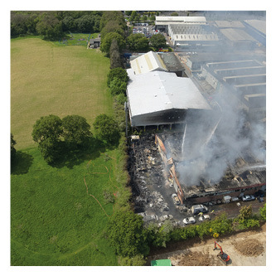

New technology to support firefighters at incidents

The ECFRS has introduced a state-of-the-art drone to their firefighting response to provide unique aerial intelligence at live incidents across Essex.
The drone will bring additional support to firefighters by providing live aerial imagery, previously not available, to help bring the fire to a safer, quicker conclusion.

