ESSEX COUNTY FIRE AND RESCUE SERVICE
RETIRED MEMBERS ASSOCIATION
NEWSLETTER AUGUST 2023
Secretary: Barry Cable,”Briarlea” Southend Road, Billericay CM11 2PR
Email: barryccable@gmail.com Telephone: 01277 624152 or mobile: 07850 984593
RMA Website: https://www.essex-fire.gov.uk/retired-members-association

The eveWaa
ESSEX COUNTY FIRE AND RESCUE SERVICE
RETIRED MEMBERS ASSOCIATION
NEWSLETTER JUNE 2023
Secretary: Barry Cable,”Briarlea” Southend Road, Billericay CM11 2PR
Email: barryccable@gmail.com Telephone: 01277 624152 or mobile: 07850 984593
RMA Website: https://www.essex-fire.gov.uk/retired-members-association

The eveWaa

___________________________________________
A night at the dogs…
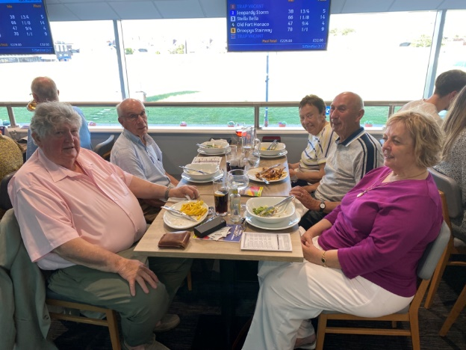
The evening at Romford Stadium on the 7th July was a great success and a good time was had by all that attended. There were a few winners but none of us had that BIG win!
The Paddock restaurant was situated on the finishing line so we all had an excellent view of the track. The three-course meal was very good and the service was excellent too.
Our thanks to Tony Pizzala for organising this event, we hope to repeat it sometime in the future.
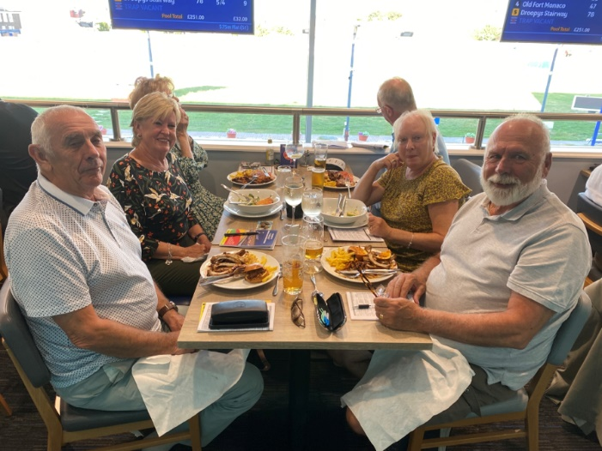

Forthcoming Events:-

The visit to Brian & Wendy Wickenden’s garden on the 2nd August will be reported in the next newsletter.
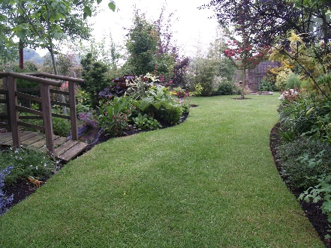
________________________________________________________________________
Warners Hotel Getaway at Studley Castle, Warwickshire
11th September 2023
Bookings for this event have now closed, however, if you are really interested, it may be worth contacting Dave Birks!
Dave Birks: 01702 528355
dave-jean-birks@supanet.com
A DATE FOR YOUR DIARY….
7th December 2023 our Christmas Lunch. This year we decided to hold our Christmas Lunch at The Lion Inn at Boreham in their private dining room. We had an excellent lunch there in the summer of 2022 and we know the food and service is of a very high standard.
Further details will be included in a future newsletter.
☛HAVE YOU REMEMBERED … TO REGISTER YOUR INTEREST IN JOINING THE GROUP TO SEE “HAMILTON” AT THE VICTORIA PALACE THEATRE ON THURSDAY 16th NOVEMBER. £95 PER PERSON FOR COACH AND SHOW
PLEASE EMAIL JANET CALDWELL ASAP IF YOU WANT TO GO TO THIS EVENT. Janetcaldwell123@btinternet.com

Following our recent visit to Romford Stadium……
Did you know that greyhounds make great pets…
The journey doesn’t stop when the racing does…
Greyhounds are affectionate, loving, playful and very clever and make wonderful pets!
Known for their speed and the belief they need lots of exercise, however they don’t need a huge amount of exercise… these gentle, affectionate animals love snuggling on the sofa and napping, but will also happily go on long walks with you too!
Whether you work, have children or other pets, the rehoming partners work hard to match the right greyhound with the right family, ensuring they are happy and healthy!
For further details please visit –
www.rgoa.org.uk or greyhoundtrust.org.uk
Details taken from Romford Stadium Program

EXTRACT FROM THE JULY EDITION OF ECFRS NEWS
Staying safe around the water this summer
Every year people drown at home and on holiday because they don’t take simple precautions. We want people to enjoy the water safely.
Help us to reduce summer tragedies this year by spreading the following water safety advice.
Look out for lifeguards - if you’re looking to enter the water, find a lifeguarded swimming-site
It’s colder than it looks - water is often much colder than it looks. Cold water can affect your ability to swim and self-rescue
Don’t go too far - always swim parallel to the shore
It’s stronger than it looks - currents in the water can be very strong. If you find yourself caught in a riptide don’t swim against it because you’ll tire yourself out. Swim with the current and call for help.
Bring a friend - always bring a friend when you go swimming so they can help if something goes wrong
OBITUARIES
CAROLE BESTER
We are very sorry to have to bring you the very sad news that RMA member Carole Bester died at 5am on the 12th July 2023. Carole was part on the Secretariat at ECFRS Headquarters at Hutton and supported the RMA at many of the events.
Carole’s daughter Hilary writes as follows:
“….my mother often spoke very fondly about her time working in the fire service and being part of the retirement group. Please, if possible, could you make the relevant parties aware that my mum’s funeral was held on Wednesday 2nd August at 11.30 a.m. at the South Essex Crematorium in Corbets Tey….”

PAT JONES
The following message was received from Margaret Jones on the 13th July:
“I’m very sorry to have to tell you that Pat Jones, former ACO (Admin) passed away last week.”
His funeral was on Monday 24th July in the Abbey Chapel at the West Suffolk Crematorium, with a reception afterwards at the Bury St Edmunds Golf Club.

